Preparation of Papers for ATEE 2008 Proceedings

First A. Author^{1,2}, Second B. Author, Jr.², and Third C. D. Author^{3,4}, Member, IEEE

¹National Institute of Standards and Technology, Boulder, CO 80305, USA
²Physics Department, University of Colorado, Boulder, CO 80309, USA
³Metallurgical and Materials Engineering Department, Colorado School of Mines, Golden, CO 80401, USA
⁴National Institute for Materials Science, Tsukuba, Ibaraki 305, Japan

These instructions give you guidelines for preparing 4 or 6 pages papers for ATEE 2008 Proceedings. Use this document as a template if you are using Microsoft Word 6.0 or later. Otherwise, use this document as an instruction set. This template is useful for estimating the length of conference-related papers, but its use is optional. Paper titles should be written in uppercase and lowercase letters. Avoid writing long formulas with subscripts in the title; short formulas that identify the elements are fine (e.g., “Nd-Fe-B”). Do not begin a title with the word “On.” Avoid starting a title with articles like “The.” Do not write “(Invited)” in the title. Full names of authors are preferred, but initials may be used instead. Put a space between authors’ initials. Department names are optional in the affiliations. Do not give street addresses in the affiliations (except for authors with no institutional affiliation). Define all symbols used in the abstract, and once again in the text. Do not cite references in the abstract.

Index Terms—About four key words or phrases in alphabetical order, separated by commas.

Introduction
T
his document is a template for Microsoft Word versions 6.0 or later. Use of this document as a template is optional.
When you open ATEE_template_en.doc, select “Print Layout” from the “View” menu in the menu bar (View > Print Layout). Then type over sections of ATEE_template_en.doc or cut and paste from another document and then use markup styles. The pull-down style menu is at the left of the Formatting Toolbar at the top of your Word window (for example, the style at this point in the document is “Text”). Highlight a section that you want to designate with a certain style; then select the appropriate name on the style menu. The style will adjust your fonts and line spacing. Use italics for emphasis; do not underline.
To insert images in Word, position the cursor at the insertion point and either use Insert > Picture > From File or copy the image to the Windows clipboard and then Edit > Paste Special > Picture (with “Float over text” unchecked).
Authors may prepare their papers for review using any word processor, one or two columns, single or double spaced. Please follow the writing style specified in this document.

Advanced Information on Creation of Electronic Image Files
Most authors will be able to prepare images in one of the allowed formats listed above. This section provides additional information on preparing PS, EPS, and TIFF files. No matter how you convert your images, it is a good idea to print the files to make sure nothing was lost in the process.

Scanning Images to PS and EPS
If you have a scanner, a quick way to prepare figure files is to print your figures on paper exactly as you want them to appear, scan them, and then save them to a file in PostScript (PS) or Encapsulated PostScript (EPS) formats. Use a separate file for each image. File names should be of the form FIG1.PS or FIG2.EPS.

Scanning Images to TIFF
Using a scanner as above, you may save the images in TIFF format. The following specifications are the minimum requirements for TIFF images; you may use higher resolution. As a rule, if your image file size is much below 0.5 MB, your TIFF image probably does not have enough resolution.
High-contrast line figures and tables should be prepared with at least 600 dpi resolution and saved with no compression, 1 bit per pixel (monochrome), with file names of the form FIG3.TIF. To obtain a 3.45 inch figure (one column width) at 600 dpi, the figure requires a horizontal size of 2070 pixels.
Photographs and grayscale figures should be prepared with at least 220 dpi resolution and saved with no compression, 8 bits per pixel (grayscale). To obtain a 3.45 inch figure (one column width) at 220 dpi, the figure should have a horizontal size of 759 pixels.
Color figures should be prepared with at least 400 dpi resolution and saved with no compression, 8 bits per pixel (palette or 256 color). To obtain a 3.45 inch figure (one column width) at 400 dpi, the figure should have a horizontal size of 1380 pixels.

Printing images to PS Files
You may create PostScript figures by “printing” them to files. First, download a PostScript printer driver from http:// www.adobe.com/support/downloads/#Printer (for Windows and Macintosh) and also install the “PPD Files: Adobe” printer definition. In Word, paste your figure into a new document. Print to a file using the PostScript printer driver. File names should be of the form FIG5.PS. Use “Open Type” fonts when creating your figures, if possible: Times Roman, Helvetica, Helvetica Narrow, Courier, Symbol, Palatino, Avant Garde, Bookman, Zapf Chancery, Zapf Dingbats, and New Century Schoolbook.

Converting PDF to TIFF
Experienced computer users can convert figures and tables from their original format to TIFF. Some useful image converters are Adobe Photoshop, Corel Draw, and Microsoft Photo Editor, an application that is part of Microsoft Office (look for C:\Program Files\Common Files\Microsoft Shared\ PhotoEd\PHOTOED.EXE. (You may have to custom-install Photo Editor from your original Office disk.)
If you own Adobe Acrobat, you may convert many types of files to PDF. For example, you may print a PowerPoint PPT file to PDF. You may then convert a figure in the PDF file to TIFF with Adobe Acrobat or Reader: Use the Snapshot Tool to first select the figure. Then View > Zoom To a large magnification (e.g., 1600%). Then Edit > Copy to the Windows clipboard. Open Microsoft Photo Editor, Edit > Paste as New Image, crop, and adjust resolution as above.
Alternatively, you may open the PDF in PhotoShop. Set the resolution to open at 1200 dpi. Note that the obvious way to convert PPT to TIFF gives poor results: In PowerPoint, File > Save As > Save as type TIFF.

Saving Files in TIFF
Most graphing programs allow you to save graphs in TIFF; however, you often have no control over compression or number of bits per pixel. You should open these image files in a program such as Microsoft Photo Editor and re-save them using no compression, either 1 or 8 bits, and either 600 or 220 dpi resolution (File > Properties; Image > Resize). See Section III.C for an explanation of number of bits and resolution.

Using Print Screen
If your graphing program cannot export to TIFF, you can use the Print Screen function. Set your monitor to its highest resolution. Adjust the magnification so that you can view the entire image on the screen. (In PowerPoint, you may use Slide Show to get a full-screen image.) Move the cursor so it is out of the way. Press “Print Screen” on your keyboard; this copies the screen image to the Windows clipboard. Open Microsoft Photo Editor and click Edit > Paste as New Image. Crop the image (click Select button; select the part you want, then Image > Crop). Adjust the properties of the image (File > Properties) to get a width of 3.45 inches. Save the file (File > Save As) in TIFF with no compression (click “More” button).

Converting WMF to TIFF
A way to convert a figure from Windows Metafile (WMF) to TIFF is to paste it into Microsoft PowerPoint, save it in JPG format, open it with Microsoft Photo Editor or similar converter, and re-save it as TIFF.

Units
Use either SI (MKS) or CGS as primary units. (SI units are strongly encouraged.) English units may be used as secondary units (in parentheses). This applies to papers in data storage. For example, write “15 Gbit/cm² (100 Gbit/in²).” An exception is when English units are used as identifiers in trade, such as “3½ in disk drive.” Avoid combining SI and CGS units, such as current in amperes and magnetic field in oersteds. This often leads to confusion because equations do not balance dimensionally. If you must use mixed units, clearly state the units for each quantity in an equation.
The SI unit for magnetic field strength H is A/m. However, if you wish to use units of T, either refer to magnetic flux density B or magnetic field strength symbolized as µ₀H. Use the center dot to separate compound units, e.g., “A·m².”

Helpful Hints

Figures and Tables
It is recomended to position figures and tables at the tops and bottoms of columns. Large figures and tables may span both columns. Place figure captions below the figures; place table titles above the tables. If your figure has two parts, for example, include the labels “(a)” and “(b)” as part of the artwork. Please do not include captions as part of the figures. Do not put captions in “text boxes” linked to the figures. Do not put borders around the outside of your figures. Use the abbreviation “Fig.” even at the beginning of a sentence. Do not abbreviate “Table.” Tables are numbered with Roman numerals.

Color Figures
ATEE 2008 Proceeding will be printed in black-and-white.
Please be certain that the black-and-white print version is understandable without the color information.
Figure axis labels are often a source of confusion. Use words rather than symbols. As an example, write the quantity “Magnetization,” or “Magnetization, M,” not just “M.” However, if there is not enough room on the axis to specify the quantity, write just the symbol “M,” but define it in the figure caption.
ATEE 2008 allows two ways to designate units in graphs and tables: (1) Put units in parentheses. As in Fig. 1, for example, write “Magnetization (A/m)” or “Magnetization, M (A⋅m−¹)” (but not just “A/m”). (2) Label axes with a ratio of symbols and units. For example, write “Magnetization, M/(A⋅m−¹)” or “Temperature, T/K” (but not “Temperature/K”).
Multipliers can be especially confusing. Write “Magnetization (kA/m)” or “Magnetization (10³ A/m).” Do not write “Magnetization (A/m) × 1000” because the reader would not know whether the top axis label in Fig. 1 meant 16000 A/m or 0.016 A/m. Figure labels should be legible, approximately 8 to 12 point type when reduced to journal column width.

References
Number citations consecutively in square brackets [1]. The sentence punctuation follows the brackets [2]. Multiple references [2], [3] are each numbered with separate brackets [1]-[3]. When citing a section in a book, please give the relevant page numbers [2]. In sentences, refer simply to the reference number, as in [3]. Do not use “Ref. [3]” or “reference [3]” except at the beginning of a sentence: “Reference [3] shows ... .” Number footnotes separately in superscripts (Insert > Footnote). Place the actual footnote at the bottom of the column in which it is cited; do not put footnotes in the reference list (endnotes). Use letters for table footnotes (see Table I).
Note that ATEE 2008 referencing style is quite different from that used by most physics journals. Give all authors’ names; do not use “et al.” unless there are six authors or more. Use a space after authors’ initials. Papers that have not been published should be cited as “unpublished” [4]. Papers that have been submitted for publication should be cited as “submitted for publication” [5]. (Since the paper may not be accepted, it is best to not specify the journal.) Papers that have been accepted for publication but not yet assigned to an issue should be cited as “to be published” [6]. Please give affiliations and addresses for private communications [7].
Capitalize only the first word in a paper title, except for proper nouns and element symbols. If you are preparing a conference-related paper and are short of space, you may omit paper titles. However, paper titles are helpful to your readers and are strongly recommended. For papers published in translation journals, please give the English citation first, followed by the original foreign-language citation [8].
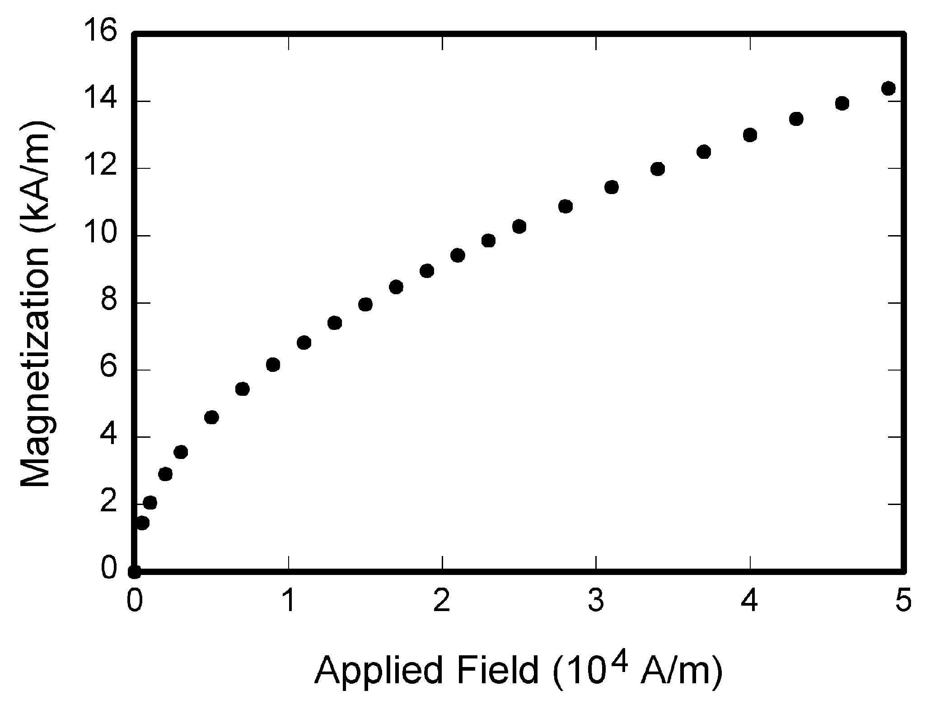
Fig. 1. Magnetization as a function of applied field. Note that “Fig.” is abbreviated. There is a period after the figure number, followed by two spaces. It is good practice to explain the significance of the figure in the caption.
Adequacy of references is one of many factors considered by Transactions reviewers. One indication of timeliness and suitability is whether citations include recent articles that have appeared in the Transactions.

Abbreviations and Acronyms
Define abbreviations and acronyms the first time they are used in the text, even after they have already been defined in the abstract. Abbreviations such as IEEE, SI, ac, and dc do not have to be defined. Abbreviations that incorporate periods should not have spaces: write “C.N.R.S.,” not “C. N. R. S.” Do not use abbreviations in the title unless they are unavoidable (for example, “IEEE” in the title of this article).

Equations
If you are using Word, use either the Microsoft Equation Editor or the MathType add-on (http://www.mathtype.com) for equations in your paper (Insert > Object > Create New > Microsoft Equation or MathType Equation). “Float over text” should not be selected.
Number equations consecutively with equation numbers in parentheses flush with the right margin, as in (1). First use the equation editor to create the equation. Then select the “Equation” markup style. Press the tab key and write the equation number in parentheses. To make your equations more compact, you may use the solidus ( / ), the exp function, or appropriate exponents. Use parentheses to avoid ambiguities in denominators. Punctuate equations when they are part of a sentence, as in

(1)

Be sure that the symbols in your equation have been defined before the equation appears or immediately following. Italicize symbols (T might refer to temperature, but T is the unit tesla). Refer to “(1),” not “Eq. (1)” or “equation (1),” except at the beginning of a sentence: “Equation (1) is ... .”
Please confine equations to one column width and break equations at appropriate algebraic symbols.

Other Recommendations
Use one space after periods and colons. Hyphenate complex modifiers: “zero-field-cooled magnetization.” Avoid dangling participles, such as, “Using (1), the potential was calculated.” [It is not clear who or what used (1).] Write instead, “The potential was calculated by using (1),” or “Using (1), we calculated the potential.”
Use a zero before decimal points: “0.25,” not “.25.” Use “cm³,” not “cc.” Indicate sample dimensions as “0.1 cm × 0.2 cm,” not “0.1 × 0.2 cm².” The abbreviation for “seconds” is “s,” not “sec.” Do not mix complete spellings and abbreviations of units: use “Wb/m²” or “webers per square meter,” not “webers/m².” When expressing a range of values, write “7 to 9” or “7–9,” not “7~9.”
A parenthetical statement at the end of a sentence is punctuated outside of the closing parenthesis (like this). (A parenthetical sentence is punctuated within the parentheses.) In American English, periods and commas are within quotation marks, like “this period.” Other punctuation is “outside”! Avoid contractions; for example, write “do not” instead of “don’t.” The serial comma is preferred: “A, B, and C” instead of “A, B and C.”
If you wish, you may write in the first person singular or plural (use the singular if you are the only author) and use the active voice (“I observed that ...” or “We observed that ...” instead of “It was observed that ...”). Better still, omit statements of observation and just report what you measured: “The susceptibility decreased with temperature” instead of “We observed that the susceptibility decreased with temperature.”
Remember to check spelling. If you are not fluent in English, please get a colleague to proofread your paper.

Some Common Mistakes
The word “data” is plural, not singular. The subscript for the permeability of vacuum µ₀ is zero, not a lowercase letter “o.” The term for residual magnetization is “remanence”; the adjective is “remanent”; do not write “remnance” or “remnant.” Use the word “micrometer” instead of “micron.” A graph within a graph is an “inset,” not an “insert.” The word “alternatively” is preferred to the word “alternately” (unless you really mean something that alternates). Use the word “whereas” instead of “while” (unless you are referring to simultaneous events). Do not use the word “essentially” to mean “approximately” or “effectively.” Do not use the word “issue” as a euphemism for “problem.”
When compositions are not specified, separate chemical symbols by hyphens; for example, “NiMn” indicates the intermetallic compound Ni_{0.5}Mn_{0.5} whereas “Ni-Mn” indicates an alloy of some composition Ni_{x}Mn_{1-x}.
Be aware of the different meanings of the homophones “affect” (usually a verb) and “effect” (usually a noun), “complement” and “compliment,” “discreet” and “discrete,” “principal” (e.g., “principal investigator”) and “principle” (e.g., “principle of measurement”). Do not confuse “imply” and “infer.”
Prefixes such as “non,” “sub,” “micro,” and “ultra” are not independent words; they should be joined to the words they modify, usually without a hyphen. There is no period after the “et” in the Latin abbreviation “et al.” The abbreviation “i.e.” means “that is,” and the abbreviation “e.g.” means “for example.”
An excellent style manual and source of information for science writers is [9]. A general IEEE style guide, Information for Authors, is available at http://www.ieee.org/ web/publications/authors/transjnl/. (The style for IEEE Transactions on Magnetics differs in some respects.)

Editorial Policy
Submission of a manuscript is not required for participation in a conference. Do not submit a reworked version of a paper you have submitted or published elsewhere.

Conclusion
A conclusion section is not required. Although a conclusion may review the main points of the paper, do not replicate the abstract in the conclusion. A conclusion might elaborate on the importance of the work or suggest applications and extensions.
- Appendix
Appendixes, if needed, appear before the acknowledgment.
- Acknowledgment
The preferred spelling of the word “acknowledgment” in American English is without an “e” after the “g.” Use the singular heading even if you have many acknowledgments. Avoid expressions such as “One of us (S.B.A.) would like to thank ... .” Instead, write “S.B.A. thanks ... .” This work was supported in part by the U.S. Department of Commerce under Grant BS123456 (sponsor and financial support acknowledgment goes here).
- References
- G. Eason, B. Noble, and I. N. Sneddon, “On certain integrals of Lipschitz-Hankel type involving products of Bessel functions,” Phil. Trans. Roy. Soc. London, vol. A247, pp. 529-551, Apr. 1955.
- J. Clerk Maxwell, A Treatise on Electricity and Magnetism, 3rd ed., vol. 2. Oxford: Clarendon, 1892, pp. 68-73.
- I. S. Jacobs and C. P. Bean, “Fine particles, thin films and exchange anisotropy,” in Magnetism, vol. III, G. T. Rado and H. Suhl, Eds. New York: Academic, 1963, pp. 271-350.
- T. L. Gilbert, Formulation, Foundations and Applications of the Phenomenological Theory of Ferromagnetism, Ph.D. dissertation, Illinois Inst. Tech., Chicago, IL, 1956, unpublished.
- D. P. Arnold, “Review of microscale magnetic power generation,” submitted for publication.
- S. O. Demokritov and V. E. Demidov, “Micro-Brillouin light scattering spectroscopy of magnetic nanostructures,” IEEE Trans. Magn., to be published.
- C. J. Kaufman, Rocky Mountain Research Laboratories, Boulder, CO, private communication, 2004.
- Y. Yorozu, M. Hirano, K. Oka, and Y. Tagawa, “Electron spectroscopy studies on magneto-optical media and plastic substrate interface,” IEEE Transl. J. Magn. Jpn., vol. 2, pp. 740-741, August 1987 [Dig. 9th Annual Conf. Magn. Jpn., p. 301, 1982].
- M. Young, The Technical Writer’s Handbook. Mill Valley, CA: University Science, 1989.

It is recommended that footnotes be avoided (except for the unnumbered footnote with the receipt date on the first page). Instead, try to integrate the footnote information into the text.

